**Urban Transportation**



**Beijing** has an advanced transportation network system, there were 626 public bus routes in operation in 2005 (including Mini-bus, public trolley), with a total length of 19,000 km, and 114 km in railroad. Over 20,000 public buses and over 7,0000 taxis in service.

There were altogether 2.146 million vehicles in Beijing, with 1.54 million private ones, among which 9.92 million were cars. As one of the biggest railroad transportation hubs in China, Beijing is connected with most of the large and medium cites of the country by direct trains, railroad traffic in 2005 reached 60.384 billion people/times.  Beijing was also an air traffic center with over 200 international routes leading to major cities around the world. Civil aviation totaled over 30 million people/times. Beijing International Airport, with its newly opened terminal, became one of the busiest air traffic centers in Asia.

Beijing Municipal Bureau of Statistics

<http://www.bjstats.gov.cn/esite/>

|  |  |
| --- | --- |
| France | 21 % |
| Suede | 21 % |
| Allemagne | 20 % |
| Italie | 15 % |
| Espagne | 15 % |
| USA | 13 % |
| Canada | 13 % |
| Australia | 13 % |
| UK | 7 % |
| Norvege | 3 % |
| Japon | 1 % |

Finally, the most striking in these results is the advent of a new generation more open to sharing solutions applied to the automobile. Everywhere, this solution generates interest and even if it is not called in the near future to become a dominant model, it meets a need that exists in most developed countries today.

<http://www.ipsos.fr/decrypter-societe/2014-01-15-partager-sa-voiture-tendance-mondiale>

|  |  |  |
| --- | --- | --- |
| Sweden | <http://www.samakning.se> | 180 000 users (2013) |
| France | https://www.covoiturage.fr | + 10 000 000 users (2014) |
| Germany | <http://www.mitfahrgelegenheit.de>  =  http://www.carpooling.fr | + 5 000 000 users (2013) |
| Italy | https://www.covoiturage.fr | + 10 000 000 users (2014) |
| Spain | https://www.covoiturage.fr | + 10 000 000 users (2014) |
| USA | https://www.carpoolworld.com | 290071 users (2015) |
| Canada | [www.**amigoexpress**.com](http://www.amigoexpress.com) | + 200 000 uers (2014) |
| Australia | <http://www.coseats.com> | + 30 000 users |
| UK | https://www.covoiturage.fr | + 10 000 000 users (2014) |
| Norway | https://www.covoiturage.fr | + 10 000 000 users (2014) |
| Japan | http://notteco.jp | + 15 000 users (2015) |

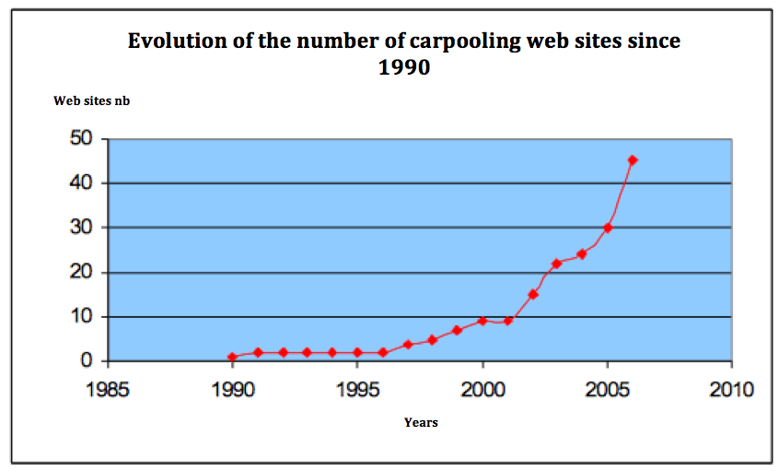

Source : <http://lara.inist.fr/bitstream/handle/2332/1453/CERTU-RE_08-01.pdf?seq>

**on the basis of a survey of travelers in Dallas–Fort Worth and Houston in Texas.**

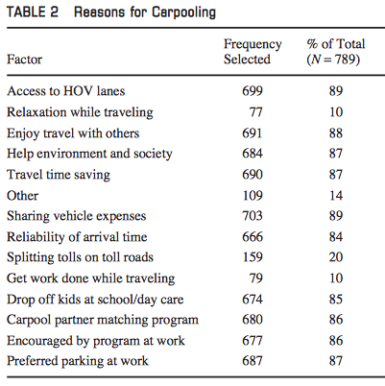

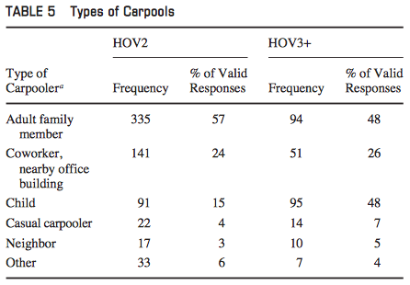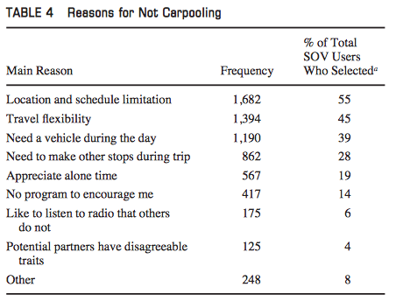

**Who Chooses to Carpool and Why? Examination of Texas Carpoolers** Jianling Li, Patrick Embry, Stephen P. Mattingly, Kaveh Farokhi Sadabadi, Isaradatta Rasmidatta, and Mark W. Burris

Government policies:

* France

La Direction générale de la concurrence, de la consommation et de la répression des fraudes (DGCCRF) rappelle, dans un communiqué du 7 février 2014, que le covoiturage est licite à condition qu’il soit gratuit ou que l’argent versé par les personnes transportées corresponde à un partage des frais générés par l’utilisation du véhicule.

The Directorate General for Competition, Consumer Affairs and Fraud Control ( DGCCRF) points out in a press release of February 7, 2014 , that carpooling is permissible under the condition that it is free or that the money paid by people transported corresponds to a cost sharing generated by the use of the vehicle.

<http://www.service-public.fr/actualites/002687.html>

* China

In January 2014, Beijing issued the carpooling regulation for small vehicles, a lawful endorsement which officially legalised carpooling in Beijing.

Carpooling needs to be built on long term cooperation between the owner of the car and the passengers; in short, people involved in carpooling know each other. Since the goal of carpooling is to reduce carbon emissions and the number of vehicles on the roads, most carpooling will be performed during commuting time. The price of carpooling

should not be expensive either.

The goal of Beijing’s legalisation of carpooling is to ease traffic congestion and conserve energy. Since the new regulation may enable black cars to earn more unjust profits, the challenge ahead for Beijing, the first city legalising carpooling, is for the government to enforce strict laws and distinguish legal carpooling from black cars.

<http://urbachina.hypotheses.org/8725>